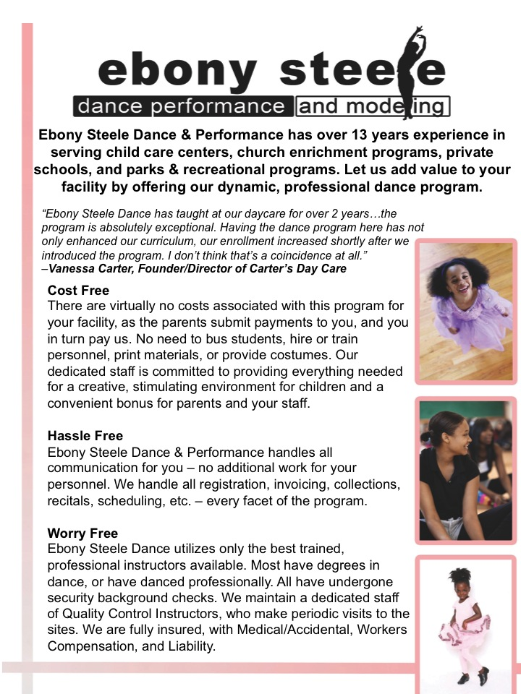

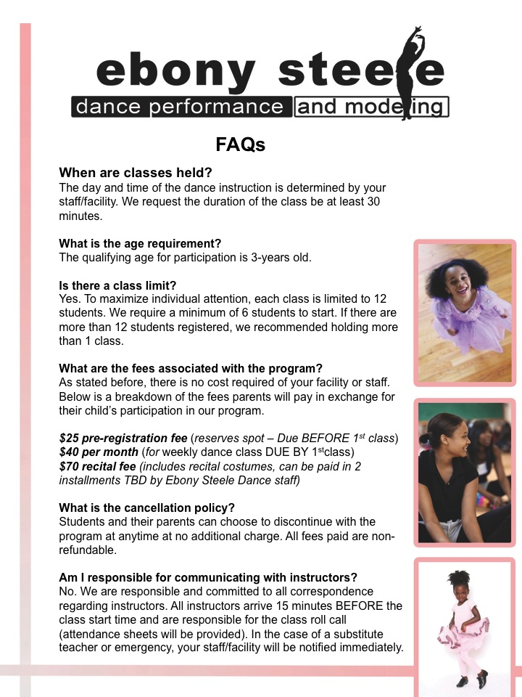

To bring **Ebony Steele Dance & Performance** to your school or daycare, email us at **atldance@ebonysteele.com.** We look forward to working with you!